LEE ACADEMY BOOSTER CLUB 4 MAN SCRAMBLE
FOR THE BENEFIT OF THE
LEE ACADEMY SPORTS PROGRAM

CLARKSDALE COUNTRY CLUB
AUGUST 15, 2020 ● SHOTGUN START 1 PM

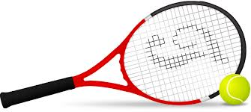
COST IS $100 PER PLAYER

TEAM
- NAME & NUMBER ______________________________________

- NAME & NUMBER ______________________________________

- NAME & NUMBER _______________________________________

- NAME & NUMBER _______________________________________

LONGEST DRIVE CONTEST
CLOSEST TO HOLE CONTEST
PUTTING CONTEST
PRIZES AWARDED AFTER COMPETITION

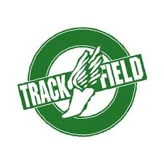
LIMITED CARTS AVAILABLE, SO PLEASE BRING YOUR OWN CART
MAIL ENTRY FORM WITH CHECK TO CLARKSDALE COUNTRY CLUB
PRO SHOP, P.O. BOX 1231, CLARKSDALE, MS 38614.
YOU MAY ALSO CALL QUINCY MORRISON AT 901-626-0581 TO ENTER
(BRING CHECK THE DAY OF THE EVENT).
CHECKS SHOULD BE MADE PAYABLE TO LEE ACADEMY

